Software Requirements Specification
Document

IT 326

1.0
August 21 2017

Rishi Saripalle

Submitted in partial fulfillment of the requirements of
IT 326: Principles of Software Engineering

Table of Contents

Table of Contents ii
Revision History iii
Document Approval iii
1. Introduction 1
1.1 Purpose 1
1.2 Scope 1
1.3 Definitions, Acronyms, and Abbreviations 1
1.4 References 1
1.5 Overview 1
2. General Description 2
2.1 Product Perspective 2
2.2 User Characteristics 2
2.3 System Environment 2
2.4 General Constraints 2
2.5 Assumptions and Dependencies 2
3. Specific Requirements 2
3.1 Functional Requirements 3
3.2.1 {Feature Name or Use Case Name} 3
3.2.2 {Feature Name or Use Case Name} 3
3.3 Non-Functional Requirements 3
3.3.1 Performance 3
3.3.2 Reliability 3
3.3.3 Availability 3
3.3.4 Security 3
3.3.5 Maintainability 3
3.3.6 Portability 3
3.4 Design Constraints 3
3.5 Other Requirements 3
4. Design & Development 3
4.1 Software Process Model 3
4.1.1 Introduction 3
4.1.2 Process Model 4
4.2 Sprint 1 4
4.2.1 Description 4
4.2.3 Design 4
4.1.4 Development 6

Revision History

Date | Description | Author | Comments
{date} | {Version 1} | {Your Name} | {First Revision}

Document Approval
The following Software Requirements Specification has been accepted and approved by the following:
Signature | Printed Name | Title | Date
 | {Your Name}
 | Dr. Rishi Kanth Saripalle

1. Introduction
The following subsections of the Software Requirements Specifications (SRS) document should provide an overview of the entire SRS. The thing to keep in mind as you write this document is that you are telling what the system must do – so that designers can ultimately build it. Do not use this document for design!!!

1.1 Purpose
Identify the purpose of this SRS and its intended audience. In this subsection, describe the purpose of the particular SRS and specify the intended audience for the SRS.

1.2 Scope
This subsection should:
- Identify the software product(s) to be produced by name
- Explain what the software product(s) will, and, if necessary, will not do
- Describe the application of the software being specified, including relevant benefits, objectives, and goals as precisely as possible.
- Be consistent with similar statements in higher-level specifications (for example, the System Requirement Specification), if they exist.

This should be an executive-level summary. Do not enumerate the whole requirements list here.

1.3 Definitions, Acronyms, and Abbreviations
This subsection should provide the definitions of all terms, acronyms, and abbreviations required to properly interpret the SRS. This information may be provided by reference to one or more appendixes in the SRS or by reference to other documents.

1.4 References
This subsection should:
- Provide a complete list of all documents referenced elsewhere in the SRS, or in a separate, specified document.
- Identify each document by title, report number - if applicable - date, and publishing organization.
- Specify the sources from which the references can be obtained.

This information may be provided by reference to an appendix or to another document.

1.5 Overview
This subsection should:
- Describe what the rest of the SRS contains
- Explain how the SRS is organized.

2. General Description
This section of the SRS should describe the general factors that affect 'the product and its requirements. It should be made clear that this section does not state specific requirements; it only makes those requirements easier to understand.

2.1 Product Perspective
This subsection of the SRS puts the product into perspective with other related products or
projects. (See the IEEE Guide to SRS for more details).

2.2 User Characteristics
This subsection of the SRS should describe those general characteristics of the eventual users of the product that will affect the specific requirements. (See the IEEE Guide to SRS for more details).

2.3 System Environment
This subsection of the SRS should describe those general characteristics of the eventual users of the product that will affect the specific requirements. (See the IEEE Guide to SRS for more details).

2.4 General Constraints
This subsection of the SRS should provide a general description of any other items that will
limit the developer’s options for designing the system. (See the IEEE Guide to SRS for a partial list of possible general constraints).

2.5 Assumptions and Dependencies
This subsection of the SRS should list each of the factors that affect the requirements stated in the SRS. These factors are not design constraints on the software but are, rather, any changes to them that can affect the requirements in the SRS. For example, an assumption might be that a specific operating system will be available on the hardware designated for the software product. If, in fact, the operating system is not available, the SRS would then have to change accordingly.

3. Specific Requirements
This will be the largest and most important section of the SRS. The customer requirements will be embodied within Section 2, but this section will also acts as a guide to project’s design, implementation, and testing.

Each requirement in this section should be:
- Correct and Unambiguous
- Traceable (both forward and backward to prior/future artifacts)
- Verifiable (i.e., testable)
- Prioritized (with respect to importance and/or stability)
- Complete and Consistent
- Uniquely identifiable, usually numbered such as 1.1, 1.1.1, 1.2, etc.

Attention should be paid to carefully organize the requirements presented in this section so that they may easily accessed and understood. Furthermore, this SRS is not the software design or implementation document, therefore one should avoid the tendency to over-constrain (and therefore design) the software project within this SRS.

3.1 Functional Requirements
This section describes specific features of the software project.

3.2.1 {Feature Name or Use Case Name}

Description

Actor(s)

3.2.2 {Feature Name or Use Case Name}

3.3 Non-Functional Requirements
Non-functional requirements may exist for the following attributes. Often these requirements must be achieved at a system-wide level rather than at a unit level. State the requirements in the following sections in measurable terms.

3.3.1 Performance

3.3.2 Reliability

3.3.3 Availability

3.3.4 Security

3.3.5 Maintainability

3.3.6 Portability

3.4 Design Constraints
Specify design constrains imposed by other standards, company policies, hardware limitation, etc. that will impact this software project.

3.5 Other Requirements
Catchall section for any additional requirements.

4. Design & Development
The purpose of this section is to outline how our team plans to execute the design and development of the “Warehouse” application. It will cover the software process model that we chose to follow and justify it. It will also show a diagram of this model that will provide details to our processes such as our sprint schedule and meeting frequency.

Software Process Model

Introduction
This section will briefly describes the process model chosen and any background information required to understand the rest of this section.

Process Model

4.1.2.1 Plan Description
The process model we have chosen for the development of our application is the Iterative &Incremental Model (IIM). This is a model that will grow our application incrementally through iterations (Sprint 1, 2, and 3) using various phases. We thought this would be a perfect fit for our application as we can divide each sprint and follow this cycle of planning, design, implementation, testing, and evaluation beginning of the start of each. Each iteration/sprint will last 2 weeks long.
We plan to meet on Mondays and Wednesdays when class time is allotted to work on the project, from 6:30 to 8:20 P.M. We will also be meeting on Tuesdays and Thursdays from 3 P.M. to 5 P.M. beginning at the start of the sprint, we will begin by planning and designing the specifications designated on the sprint schedule. Once that is done, we will begin implementing these new features and deploy them. We will then test these features near the end of the sprint and evaluate the system to conclude.

4.1.2.1 Plan Diagram
This elaborates on the plan description in the form of a diagram with the exact details related to the plans such as sprint schedule, meeting timeframes, cycle time (1 week, 2 weeks, etc.)

4.2 Sprint 1

Description
In the first sprint, we wanted to ensure to finalize our design plans and start building the basic tools needed to make our application work and fully lay out our plan of the application. This includes the ability to login and logout of the application, and the ability of the application to be able to read in a text file.

    - Satisfying Requirements
This sprint is going to fulfill the requirements 3.2., 3.2.2 and 3.3.3.

Design

4.2.3.1 Description
We focused on a simple design for the first sprint, as we felt the features we were implementing would be much further expanded on and integrated down the line in order to work with the rest of our use cases.

4.2.3.2 Standards, Frameworks and Tools
Tools we used in the creation of the design of the sprint were modeling tools from Microsoft Visio, and a free modeling website, gliffy.com. Standards we followed in the design of features of the sprint was UML.

4.2.3.3 Class Diagram

The class diagram showed in Figure 1 captures the vocabulary of the system in terms of Equipment – captures all the equipment leased and stored in the warehouse, Transaction – captures the transaction information related to an equipment, Aisle – captures the location of an equipment.
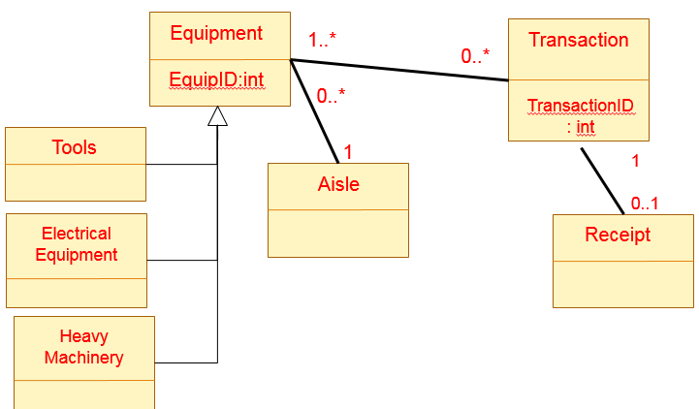
Figure 1: Equipment Class Diagram

4.1.3.4 Activity Diagram
The activity diagram shown in Figure 2 explains the activities involved and their flow for ordering an equipment.
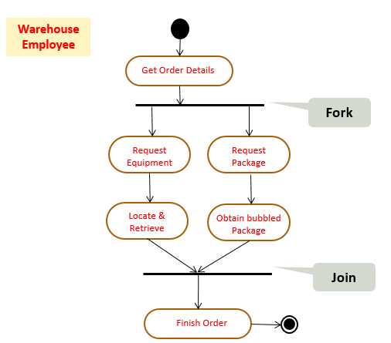
Figure 2: Equipment checkout Activity Diagram

4.1.3.5 Sequence Diagram
The sequence diagram shown in the Figure 3 illustrates the messages exchanged between the object of type “MaintaenanceEmployee” and object of type “System”.

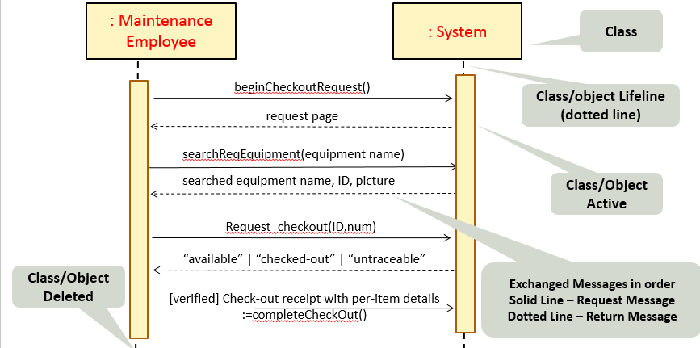
Figure 3: Checkout Sequence Diagram

4.1.3.6 State Diagram
The state diagram shown in Figure 4 explains the state of the equipment in the system.
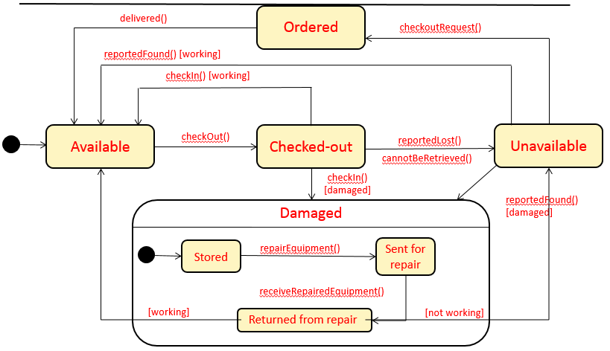
Figure 4: State Diagram of the objects of type Equipment

4.2.4 Development

4.2.4.1 Description
The features we developed in the first sprint was a simple class diagram and setting up the database for persistence of objects. These aspects we felt were vital to the later successful implementation of the core aspects of the application.

4.2.4.2 Standards, Frameworks and Tools
For the development aspect of the sprint, we used a Java IDE in order to create the classes we needed. We used the latest version of NetBeans, version 8.0.2, and Eclipse version 4.4.

Screenshots

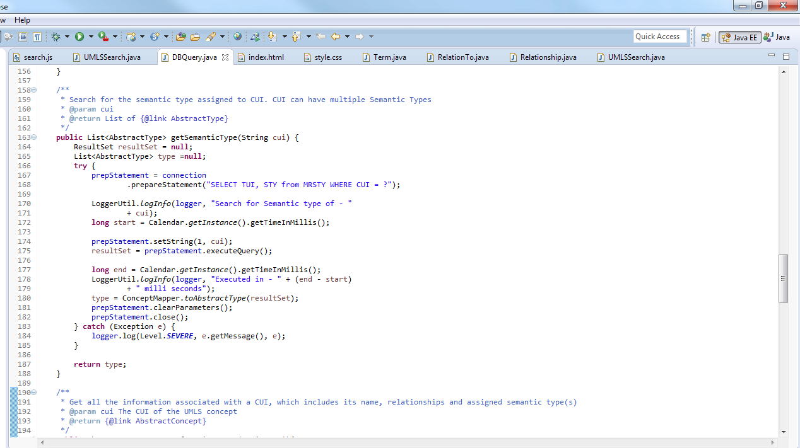

    - Testing
      - Testing Summary

Test # | Requirement # | Test Format | Test Technique | Additional Notes
T1 | 3.2.1 | Demonstration | - | Will demo on Android Tablet
T2 | 3.2.2 | Testing | Unit Testing  (Blackbox Testing) | -
T3 | 3.2.3 | Testing | Unit Testing  (Whitebox Testing)
T4 | 3.2.5 | Testing | Smoke Testing

      - Test Cases
        - T2 – Test for User Login (Test for requirement name)
          - Input
          - Output
          - Expected Output
          - Result

      - Other Testing
        - Integration Testing

